* **Trend chart for the number of complaints at monthly granularity levels**

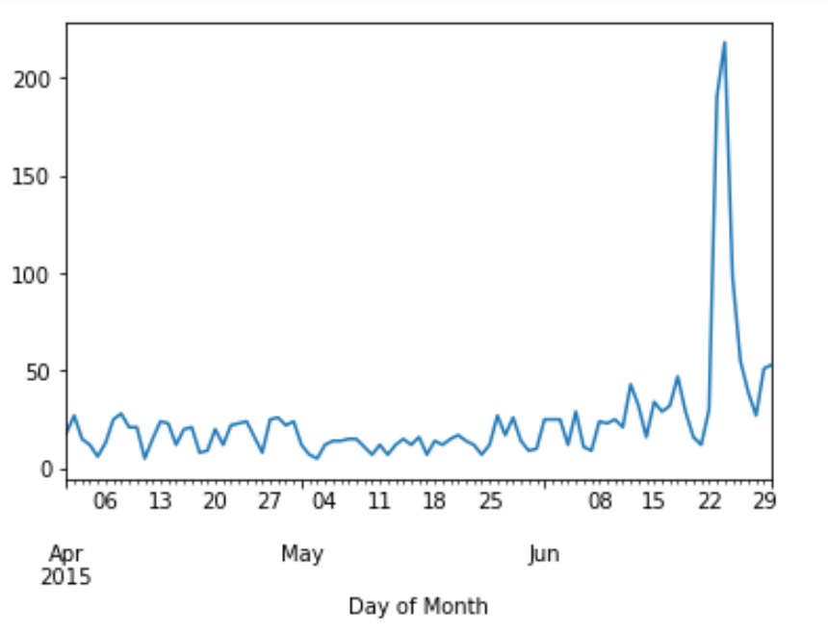

* **Provide a table with the frequency of complaint types**

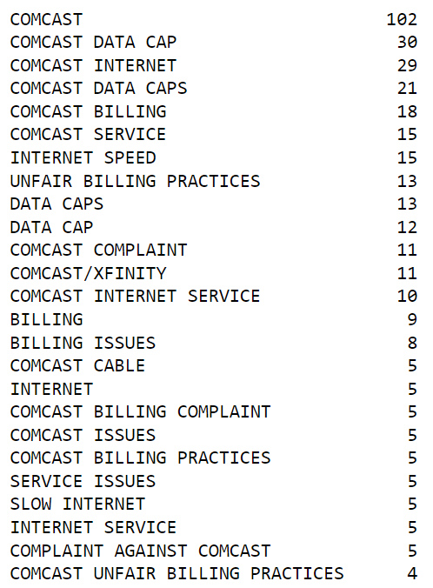

* **New categorical variable with value as Open and Closed-**

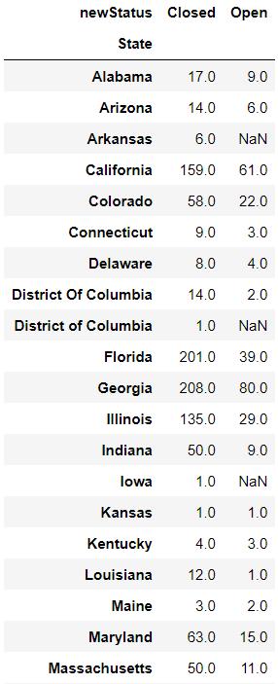

* 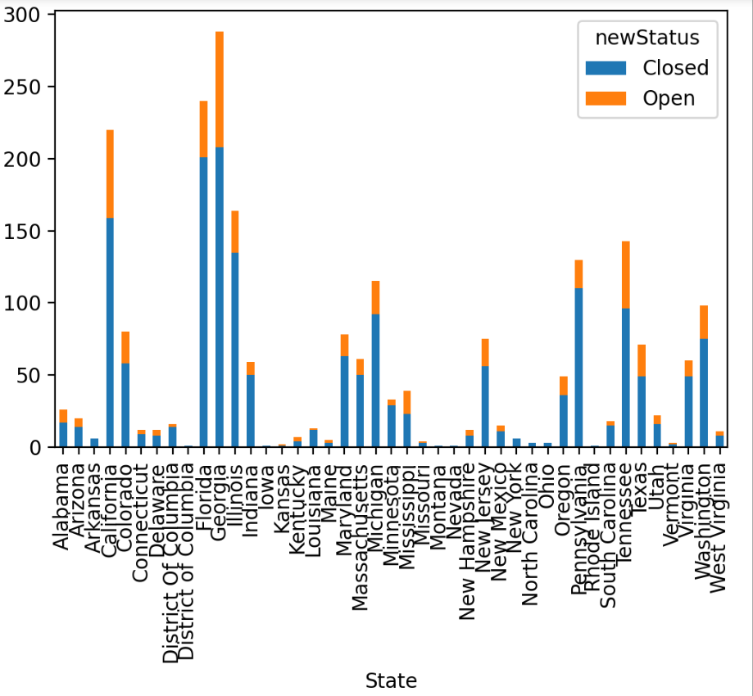**State wise status of complaints in a stacked bar chart**
* **From above chart we can conclude that Georgia has maximum number of complaints.**

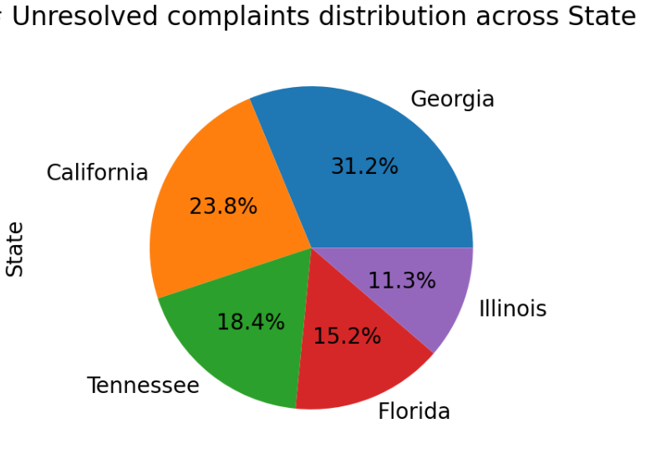

* **Percentage of complaints resolved till date, which were received through the Internet and customer care calls-**

